Idea # 6. Bent Pieces On the Table with Fusible Fleece.

Bent Pieces Christmas Table Runner 21” x 60” or your size.
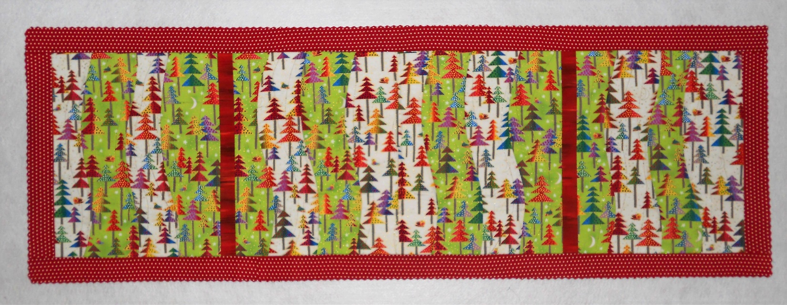
Make 4 Bent Pieces blocks: trim to your size and add sashing and border.

As shown: 2 block fabrics: ½ yd. each or 2 FQs of each. Sashing: 2 – 1 ¾” x 17 ½” (or your size).
Border 5 – 2 ½” strips. Batting: Pellon Fusible Thermolan Plus TP971F. Your size or 22” x 61”

1.Bent Pieces pattern, page 1. Make 4 blocks following instructions. Stop after #7.
2. Square all blocks to the same height (shown 17 ½”).
3. Square width on each block to 14” (+/- ½” or your size); they can be different widths.
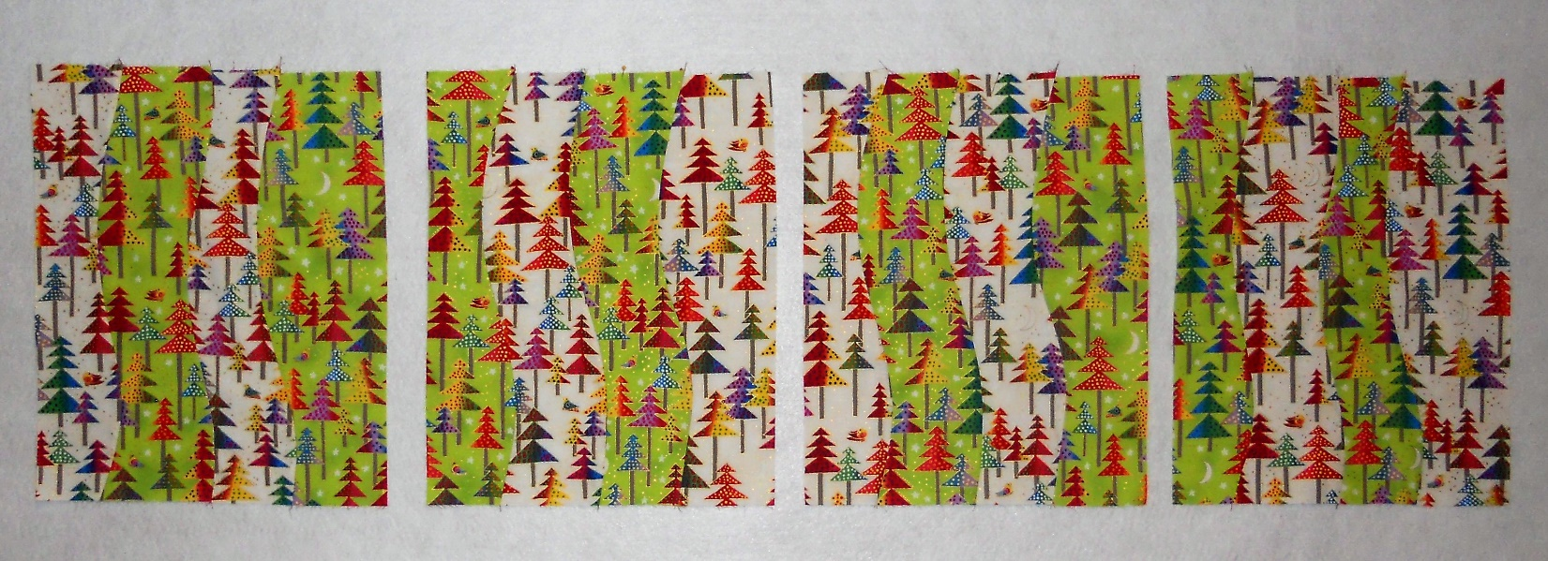

3. Stitch blocks and sashing together as shown or create a new layout.

4. Cut 2 borders segments your height. Stitch 2 short borders and press to border.
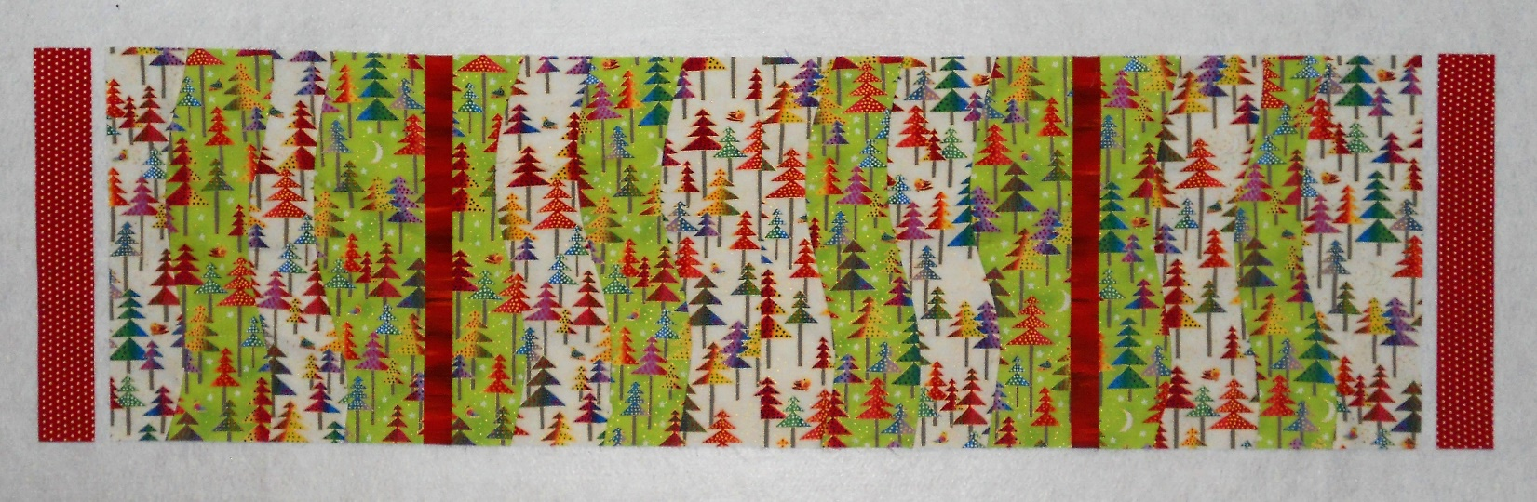

5. Measure the length. Cut 2 long borders to size, stitch to project and press to border.
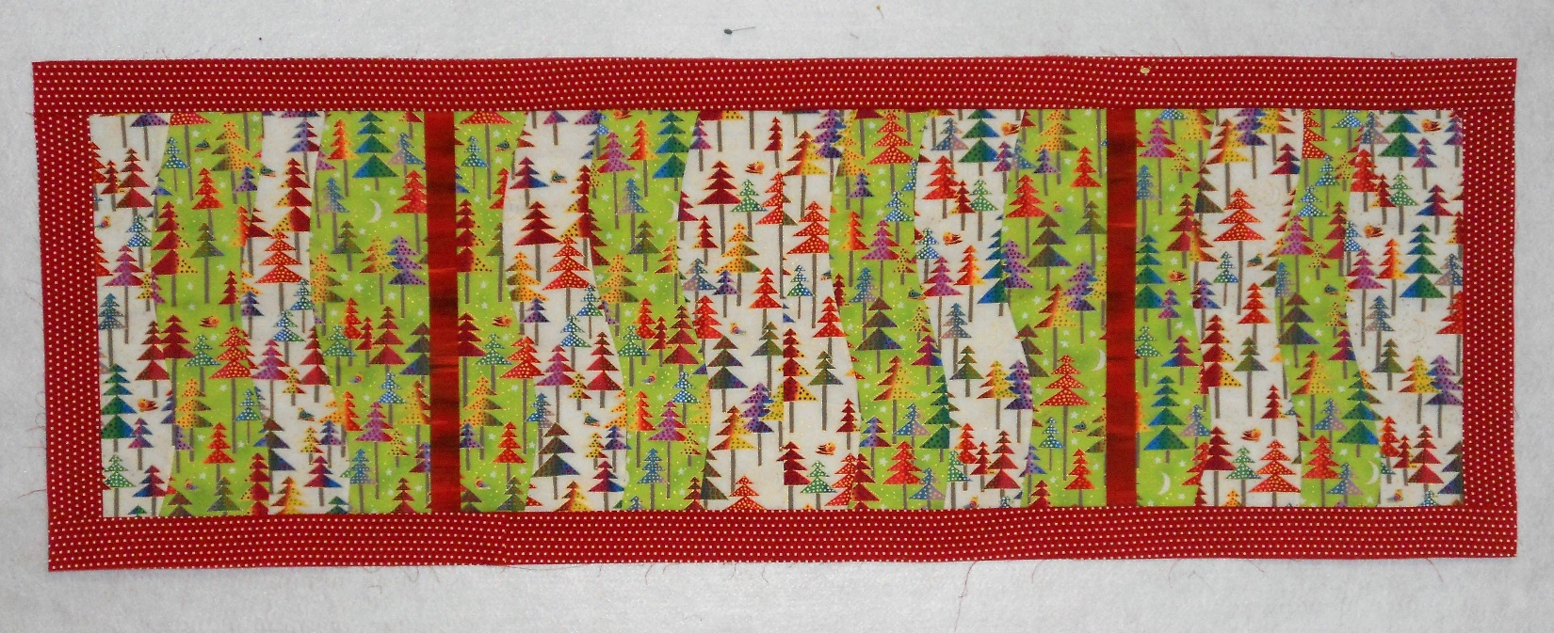

6. We fused the Thermolam and didn’t use a backing. We stitched in the ditch on the sashing and then quilted wavy lines with metallic thread and stitched in the ditch around the border.
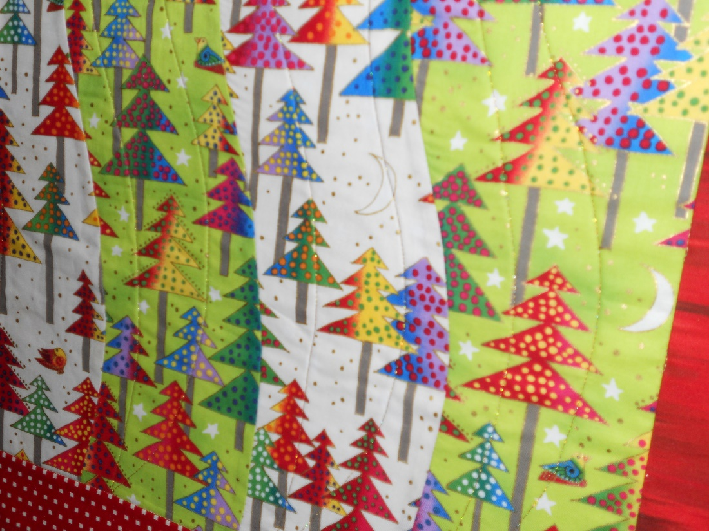

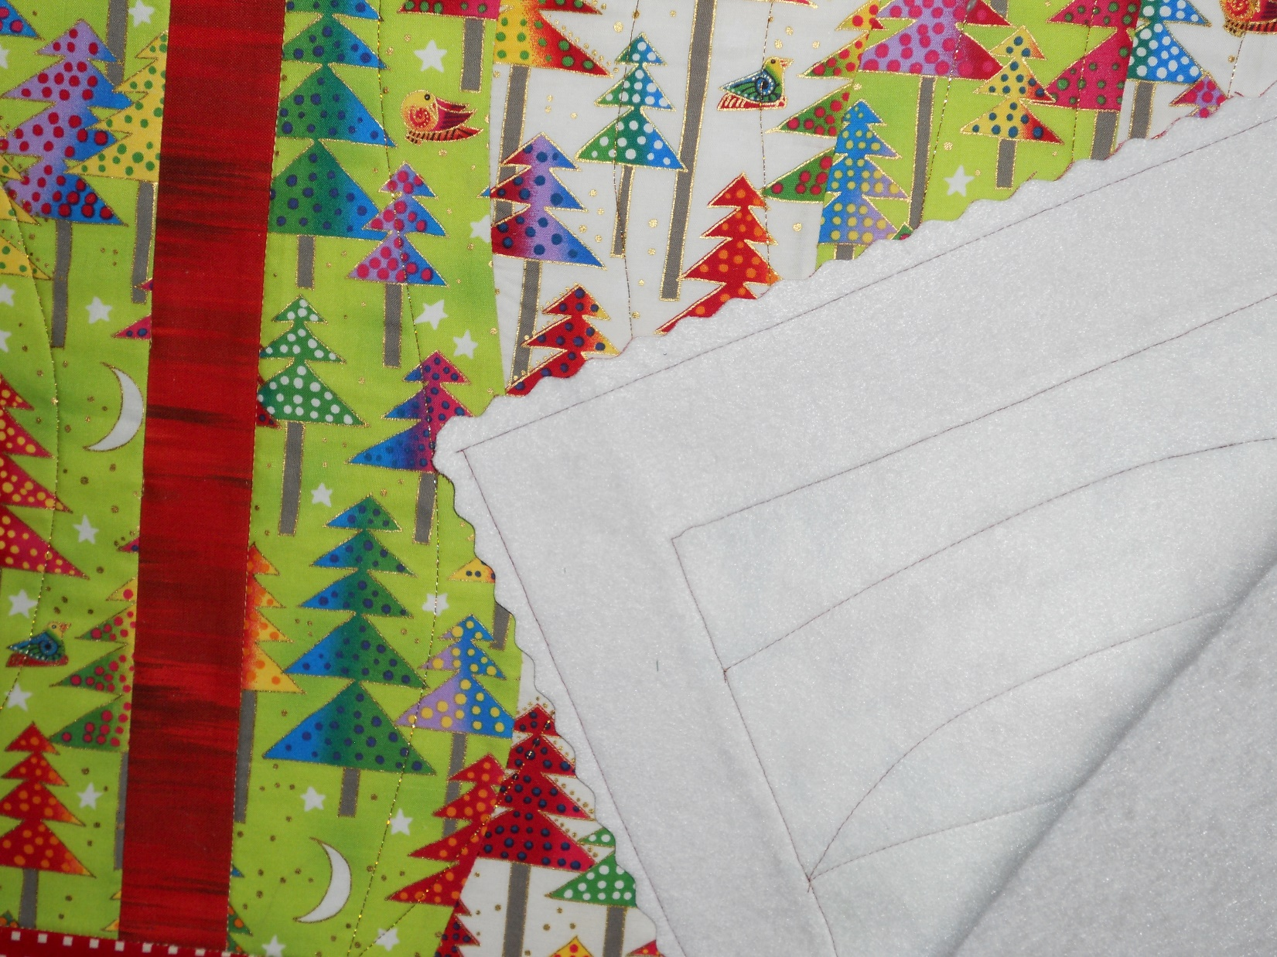
7. We squared the borders and then stitched ½” from the outside edge. Finally, we used a decorative blade ¼” from the stitching line and trimmed the border.

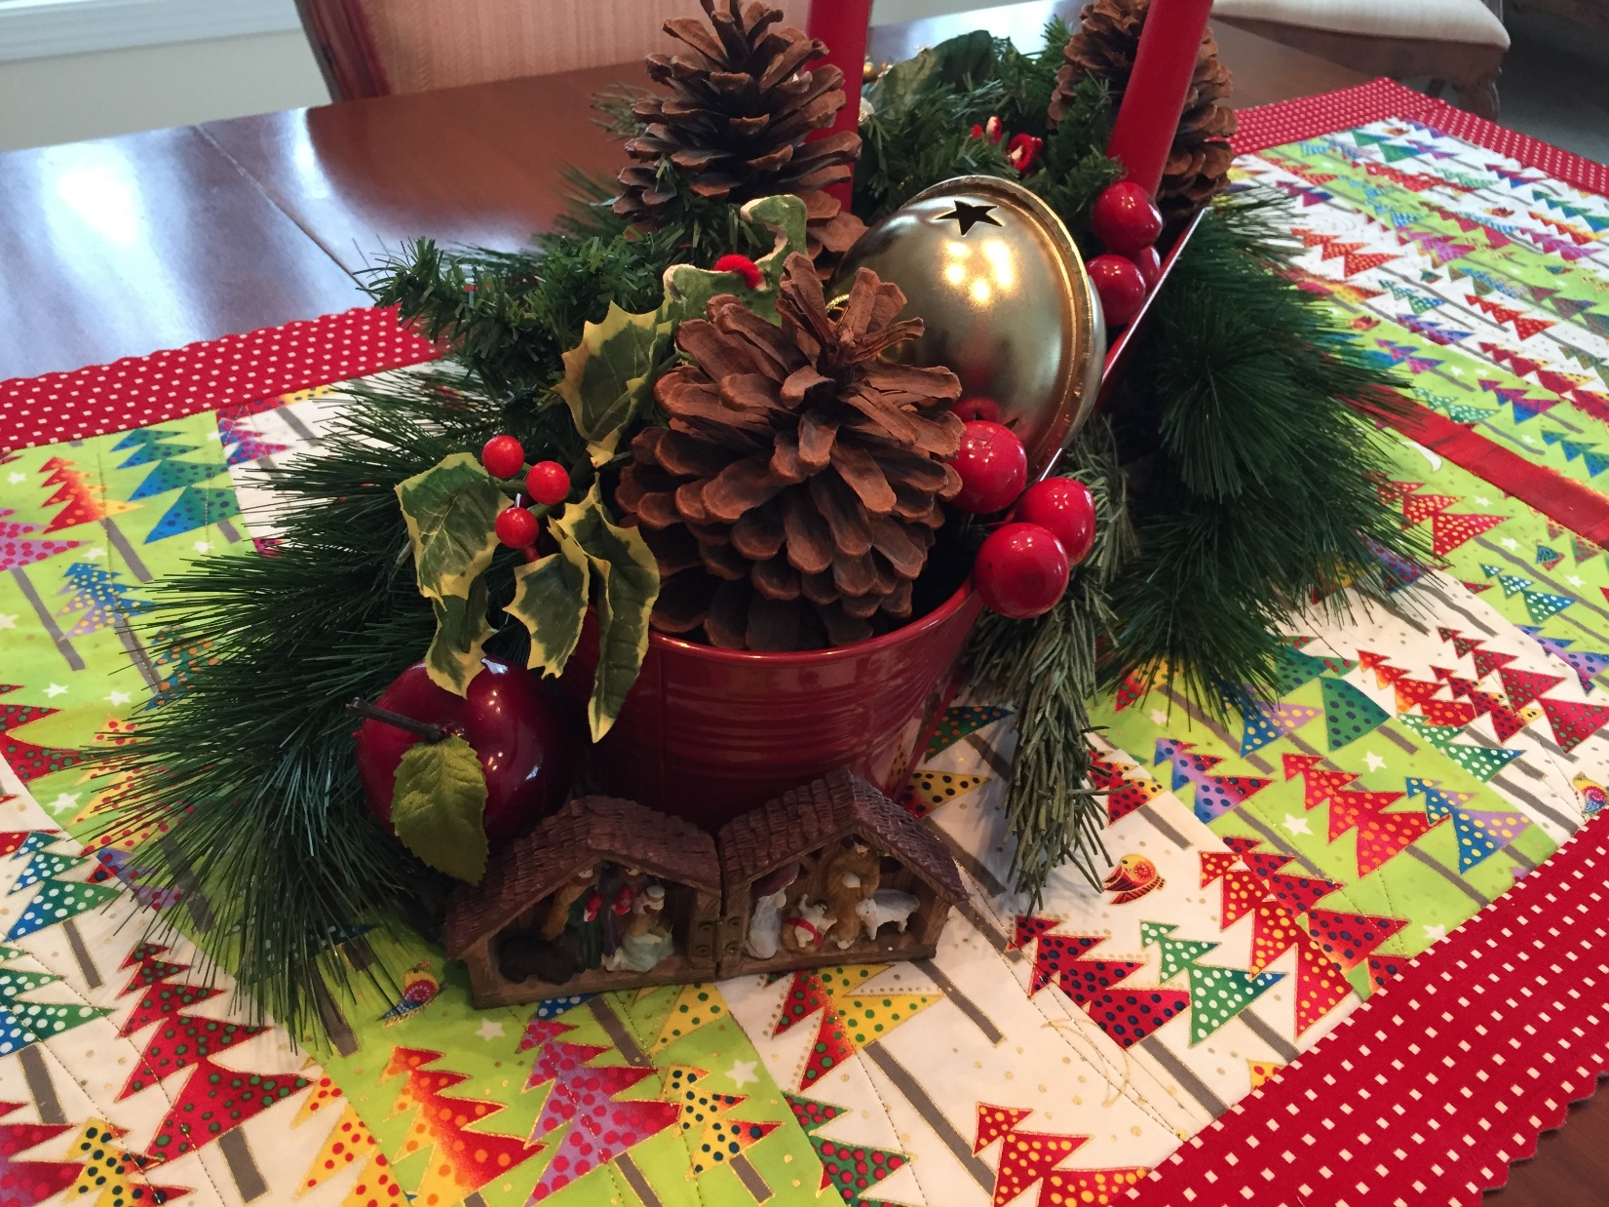
Ready to celebrate the season. Tree fabrics are Enchantment by Laurel Birch for Clothworks www.clothworks.com

